Updated 2026-02-20
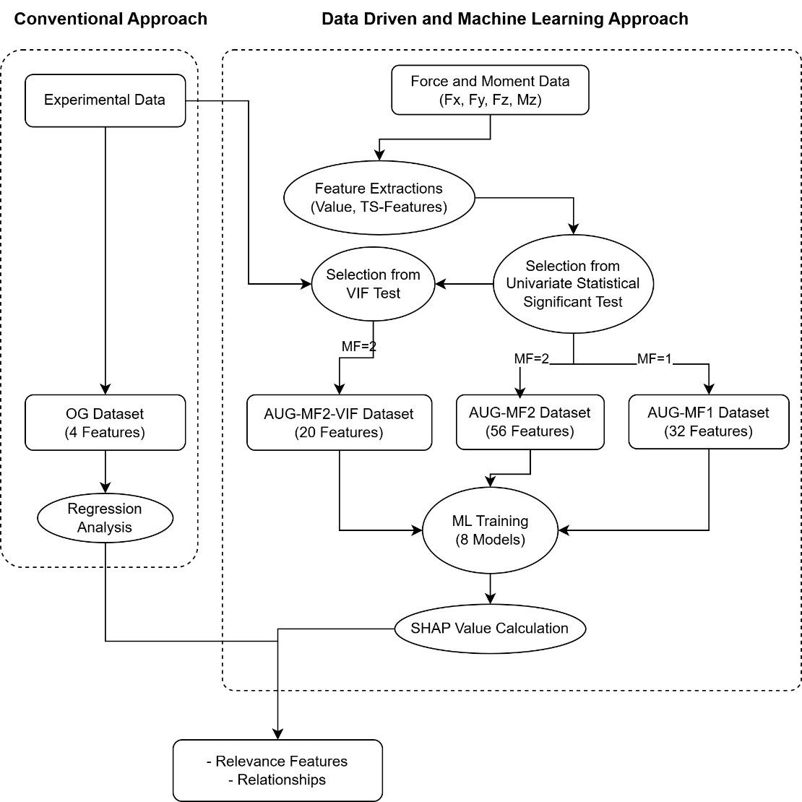
The experimental dataset comprises welding parameters (R, W, D) and the measurement location as independent variables, and the response variable $Y$as the output. The variable $Y$includes the residual stress difference between pre-weld and post-weld conditions for AA5052 and AA6061 aluminum alloys, as well as the residual stress measured at the weld center location. This information is organized into the OG dataset, which contains four input features (R, W, D, and measurement location) and the corresponding residual stress responses for each weld condition.
The remaining datasets are constructed from force and moment measurement time series. Each time series is partitioned into two segments—the dwell region and the weld region—based on the time stamp. Features are extracted from both regions using the tsfresh library, and, for the weld region, additional window-averaged values along the measurement location are computed. The resulting feature set is then reduced by univariate statistical significance tests with respect to all target variables $Y$; for each target, the top $M_{F}$features with the lowest p-values are selected as augmented features.
To further mitigate multicollinearity, a variance inflation factor (VIF) analysis is applied to the combined time-series-based and experimental features, yielding the AUG-MF2-VIF dataset, where $M_{F}=2$and the final number of features is 20. For comparison, augmented feature sets without VIF filtering are also considered: AUG-MF1 and AUG-MF2, corresponding to $M_{F}=1$and $M_{F}=2$, which contain 32 and 56 features, respectively.
The datasets are first used for exploratory data analysis to identify trends and variance in the responses. The same datasets are then employed to train a suite of eight machine learning models: an ElasticNet linear regression model, a support vector regressor with a nonlinear kernel, a k‑nearest neighbors regressor, tree‑based models including decision tree regressor, random forest regressor, gradient boosting regressor, and XGBoost, as well as a transformer‑based tabular model (TabPFN). The model development is implemented using the scikit‑learn, XGBoost, and TabPFN libraries, with Optuna employed for hyperparameter optimization. This training procedure enables a systematic investigation of the predictive capability of both the original and augmented feature sets. The trained models are subsequently analyzed using SHAP values to quantify feature relevance and to interpret how individual features contribute to the predicted residual stress responses.

Predictor | Coefficient (β) | Std. Error | t-value | p-value | 95% Confidence Interval | Significance
Constant | 0.000 | 0.044 | –0.00 | 1.000 | [–0.086, 0.086] | —
Position | –0.496 | 0.044 | –11.37 | <0.001 | [–0.582, –0.411] | ***
R | –0.174 | 0.044 | –3.98 | <0.001 | [–0.259, –0.088] | ***
W | 0.101 | 0.044 | 2.32 | 0.021 | [0.015, 0.187] | *
D | 0.053 | 0.044 | 1.22 | 0.222 | [–0.032, 0.139] | n.s.

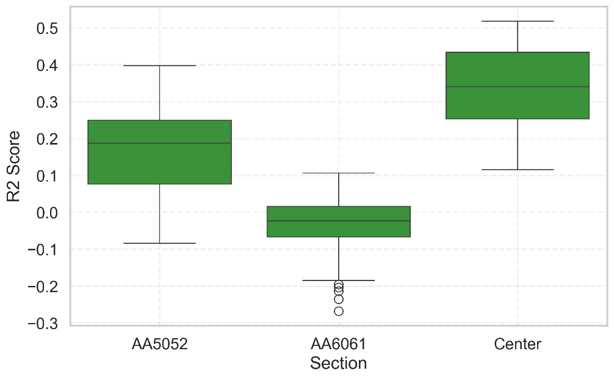
The figures summarize the coefficient of determination ($R^{2}$) obtained from the eight machine learning models and all datasets. An $R^{2}$value up to around 0.5 for predicting residual stress at the center location indicates that the models can explain roughly up to half of the variance in the residual stress at that location. For AA5052, the best $R^{2}$is lower, up to 0.4, implying that less than half of the variance in residual stress is captured by the models. In contrast, the $R^{2}$values for AA6061 are close to zero, indicating that the variation in residual stress in this region is essentially not explained by the available features in the dataset, and the models perform no better than using the mean residual stress as a predictor.
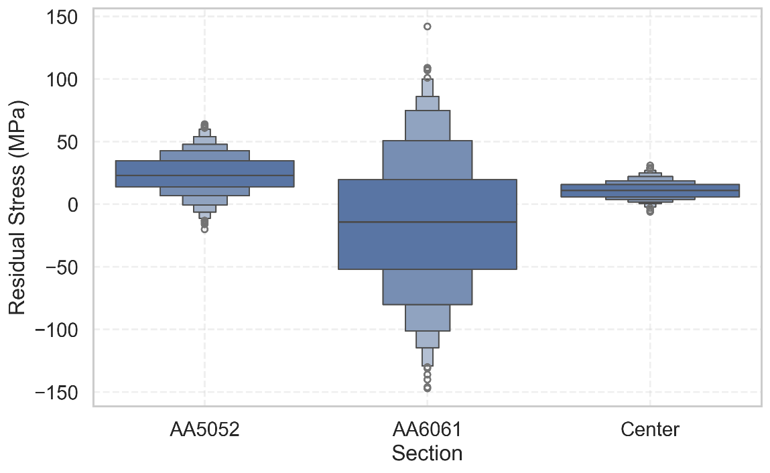
The relationship between the $R^{2}$values and the variability of the raw residual stress can also be observed from the boxplots in Figure X. In this figure, the center location and AA5052 exhibit comparatively narrower boxes and shorter whiskers, indicating lower spread in the raw stress values, whereas AA6061 shows a much wider box and longer whiskers, reflecting higher variability in the data. This greater dispersion for AA6061 is consistent with the near-zero $R^{2}$values, as the models are unable to explain the large variation in residual stress using the available features. Since the highest $R^{2}$values are obtained for predicting the residual stress at the center location, only these prediction models are used to compute feature importance via SHAP.

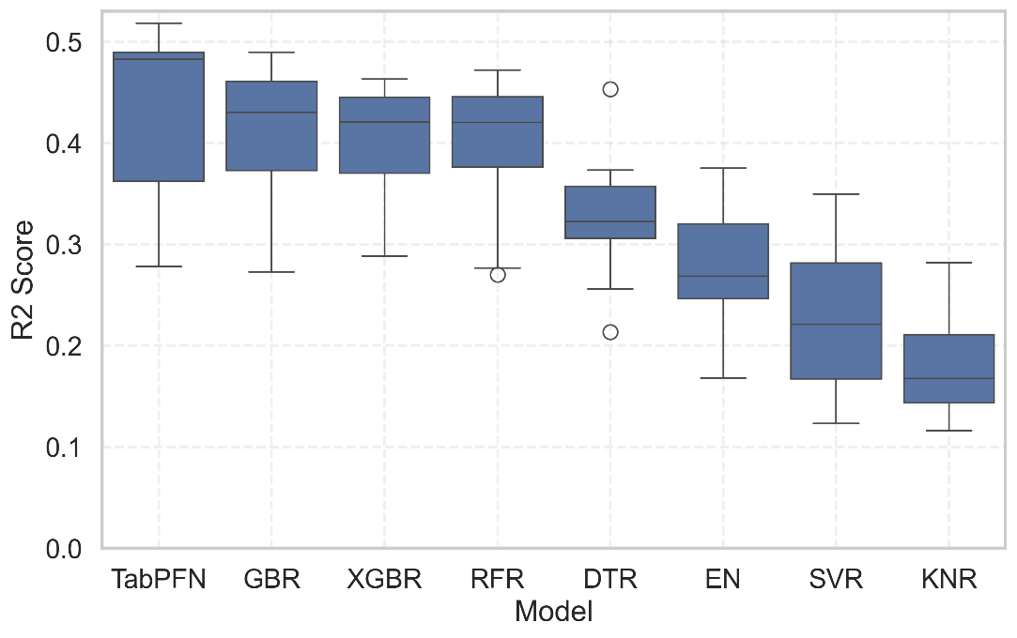
Figure X presents the $R^{2}$values for the center-value predictions obtained from the eight machine learning models. Overall, TabPFN and the tree-based models achieve the highest $R^{2}$scores, indicating superior predictive performance on this task. This result is consistent with reports that tree-based methods often deliver state-of-the-art performance on tabular data. In addition, the comparably strong performance of TabPFN suggests that transfer learning from a large corpus of prior tabular tasks can effectively capture the underlying trends in the present dataset.

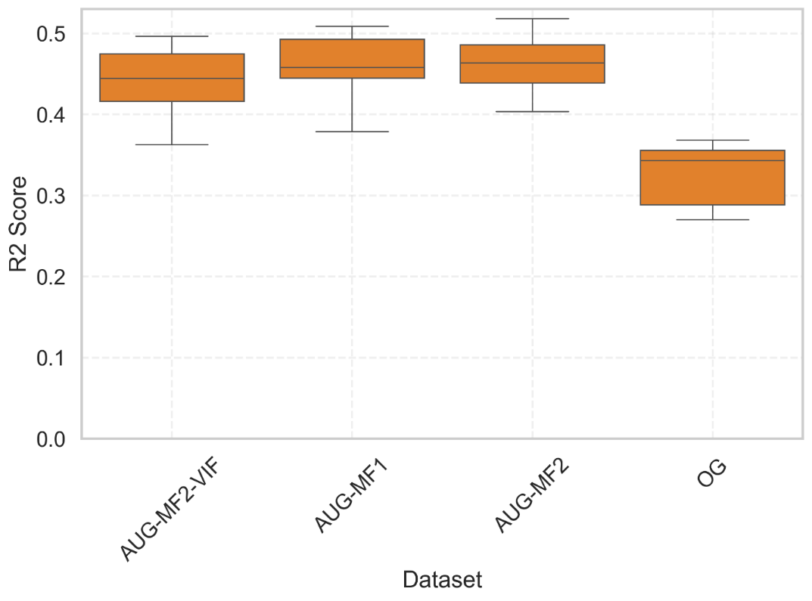
To analyze the SHAP values, we focus on the models trained on the VIF-filtered dataset, which reduces feature multicollinearity and thus yields more reliable importance attributions. As shown in Figure X, the AUG-MF2-VIF dataset does not produce prediction models with noticeably lower $R^{2}$compared to those trained on the unfiltered augmented datasets, indicating that the removal of collinear features improves interpretability without substantially degrading predictive performance. SHAP values are computed only for TabPFN and the tree-based models, as these models achieve the highest $R^{2}$scores and thus provide the most informative basis for feature importance analysis. For interpretability, SHAP contributions from features derived from $F_{z}$, $F_{x}$, $F_{y}$, and $M_{z}$are aggregated into single combined features for each corresponding signal.

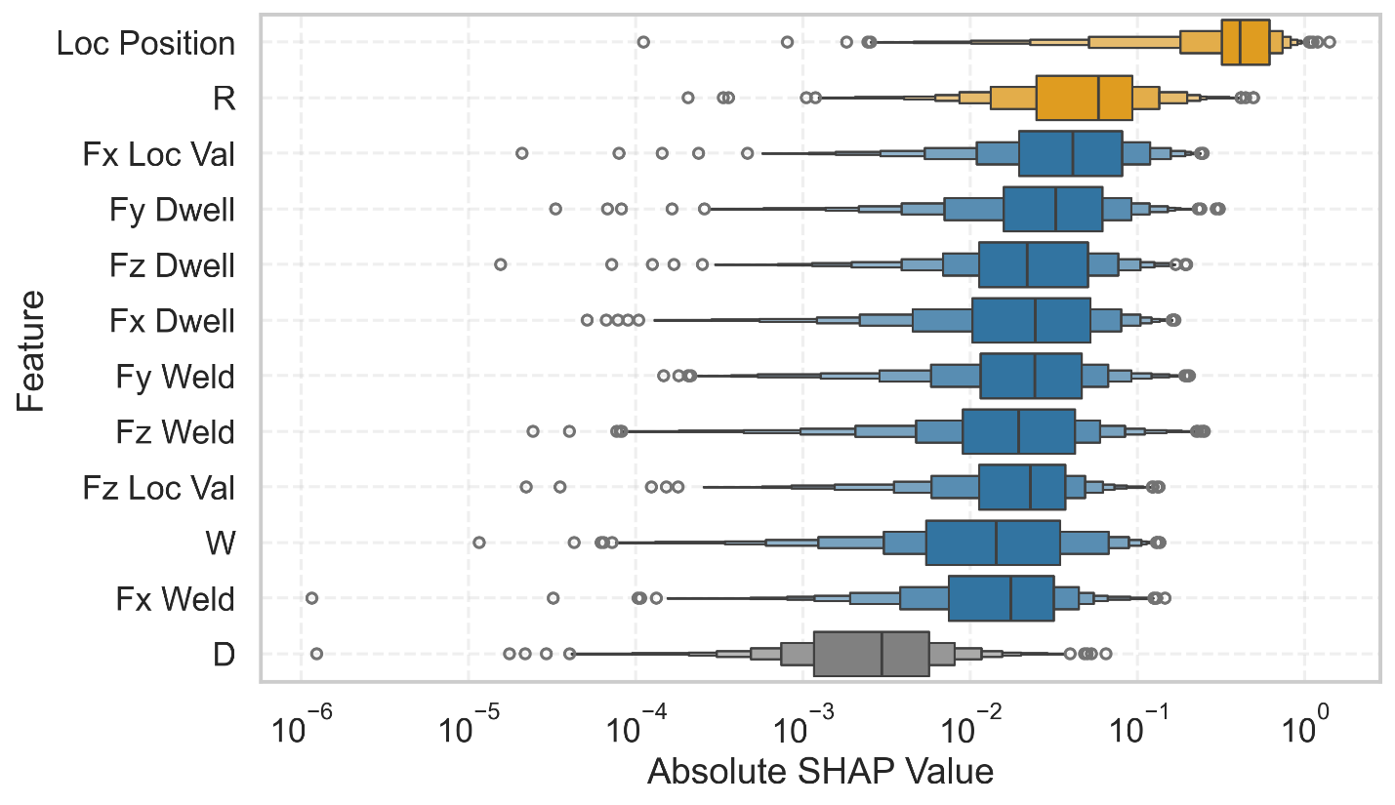
The graph presents the SHAP values corresponding to the different input features, illustrating their relative contributions to the prediction of residual stress.
- Position exhibits the highest SHAP values, indicating the strongest correlation with the residual stress along the center weld line.
- Rotational speed ranks second in importance. The remaining features—those derived from Fx, Fy, Fz, and welding speed—have a moderately lower influence compared to rotational speed and position.
- Dwell time shows the least impact on residual stress.
- The features derived from the forces during the dwell stage exhibit greater significance than the dwell time parameter itself.

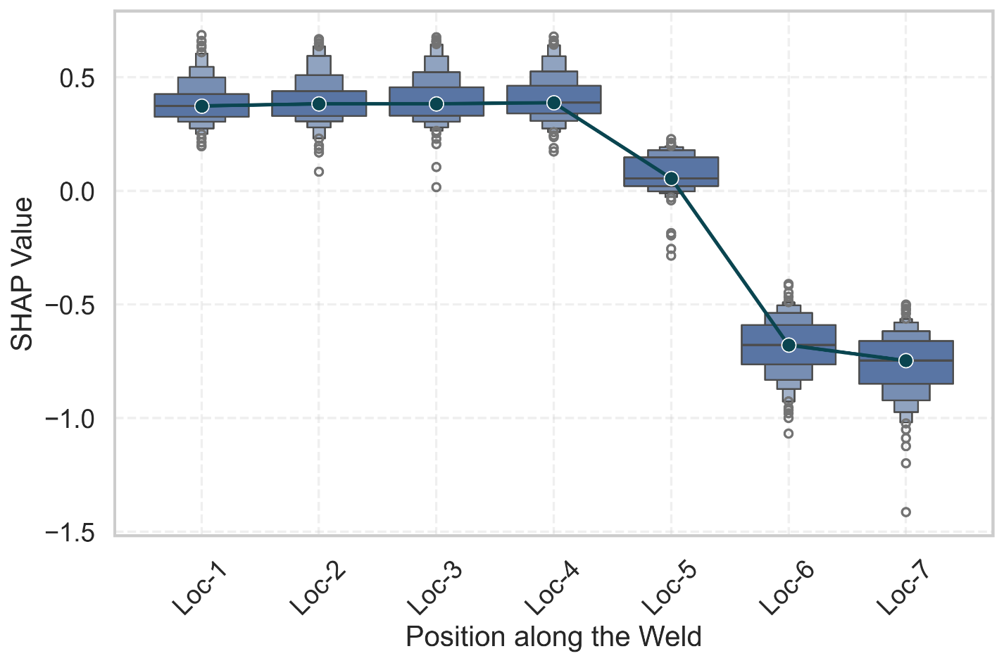
The following figure illustrates the SHAP values of position in relation to the corresponding position index.
- A clear trend can be observed between the SHAP value and the location index.
- For the first four positions, the SHAP values indicate a positive contribution, whereas the last three positions exhibit a negative contribution.
- This pattern suggests that the residual stress tends to be more tensile in the initial section and becomes more compressive toward the later positions.
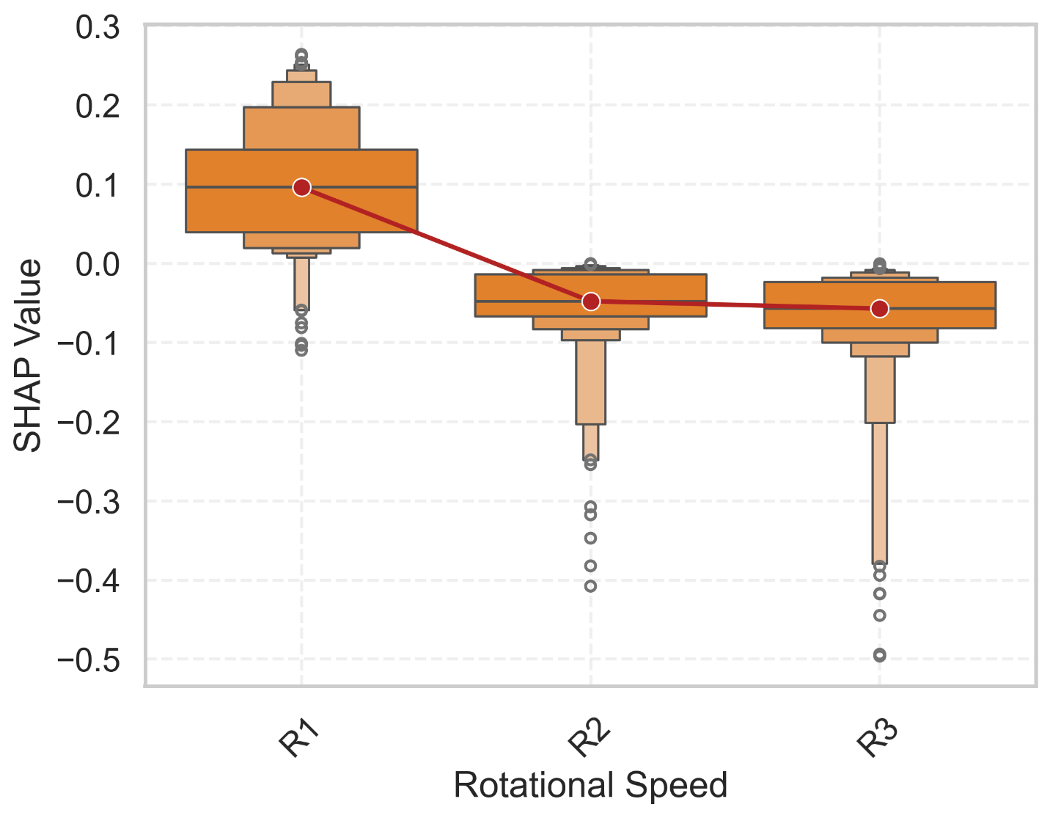
- The next figure presents the SHAP values for rotational speed, revealing an inverse relationship between rotational speed and residual stress. This indicates that as the rotational speed increases, the residual stress tends to become more compressive.
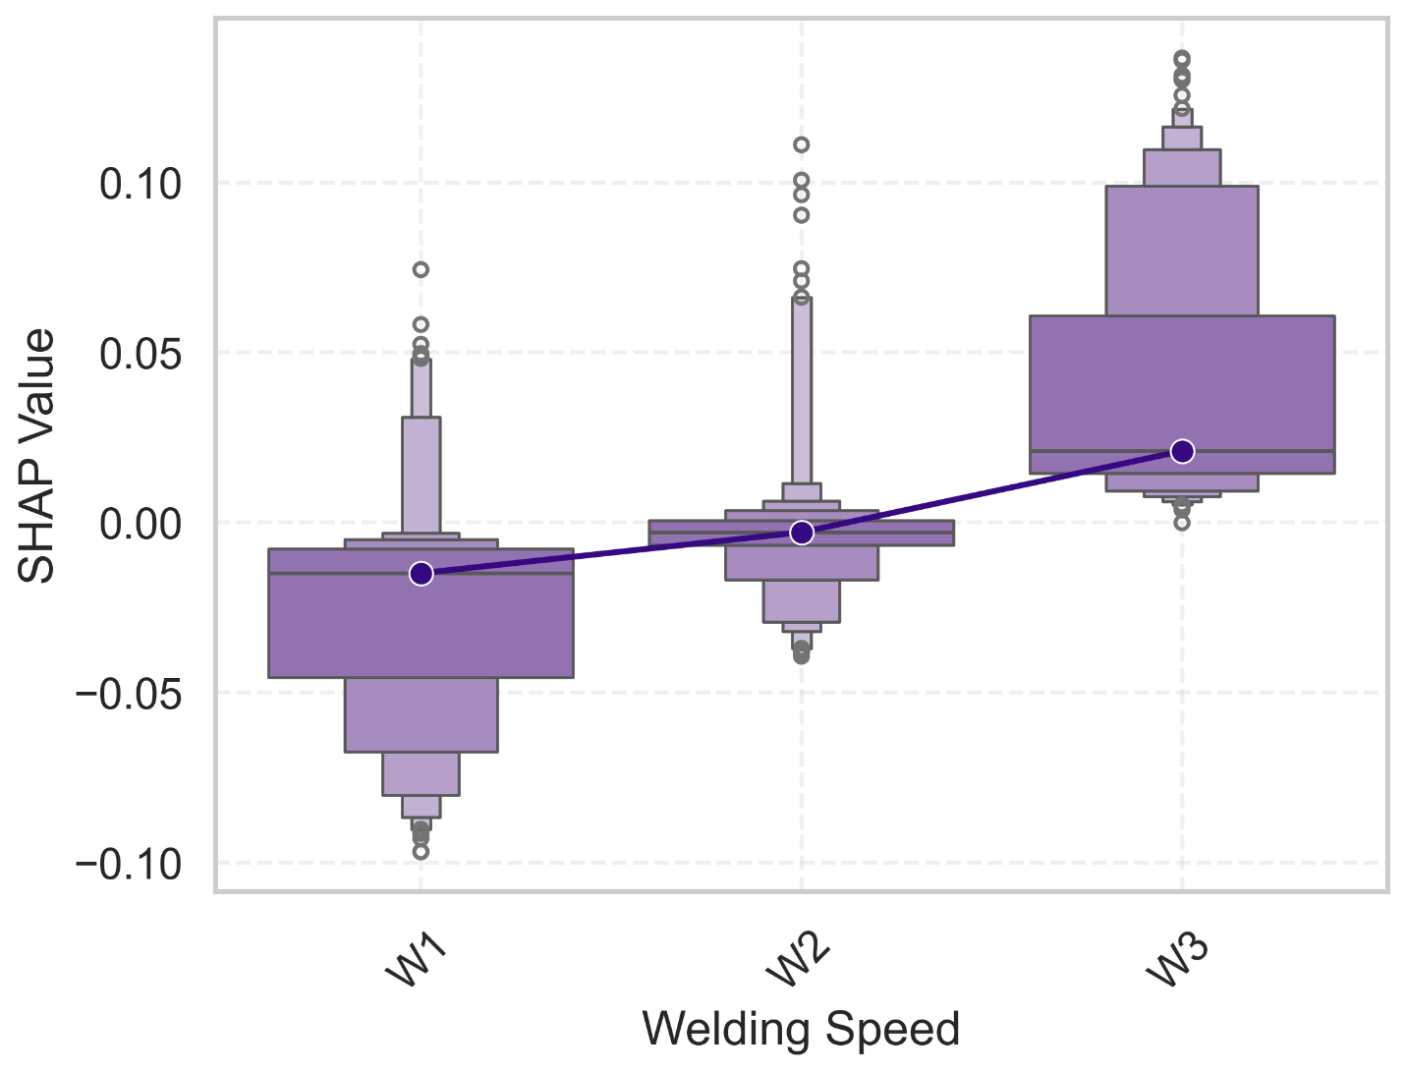
- In contrast, welding speed exhibits an opposite trend, where an increase in welding speed contributes to a higher tensile residual stress.
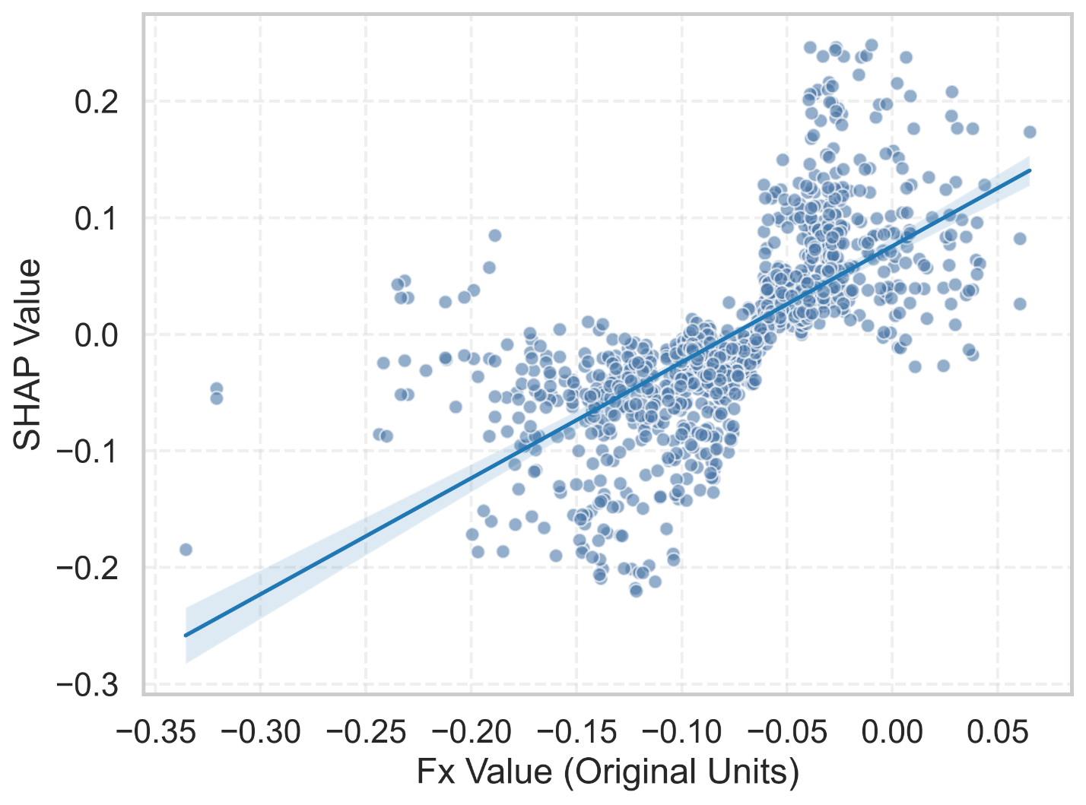
The plot of SHAP values against Fx reveals a positional correlation, indicating that the force in the x-direction varies systematically with the weld position.
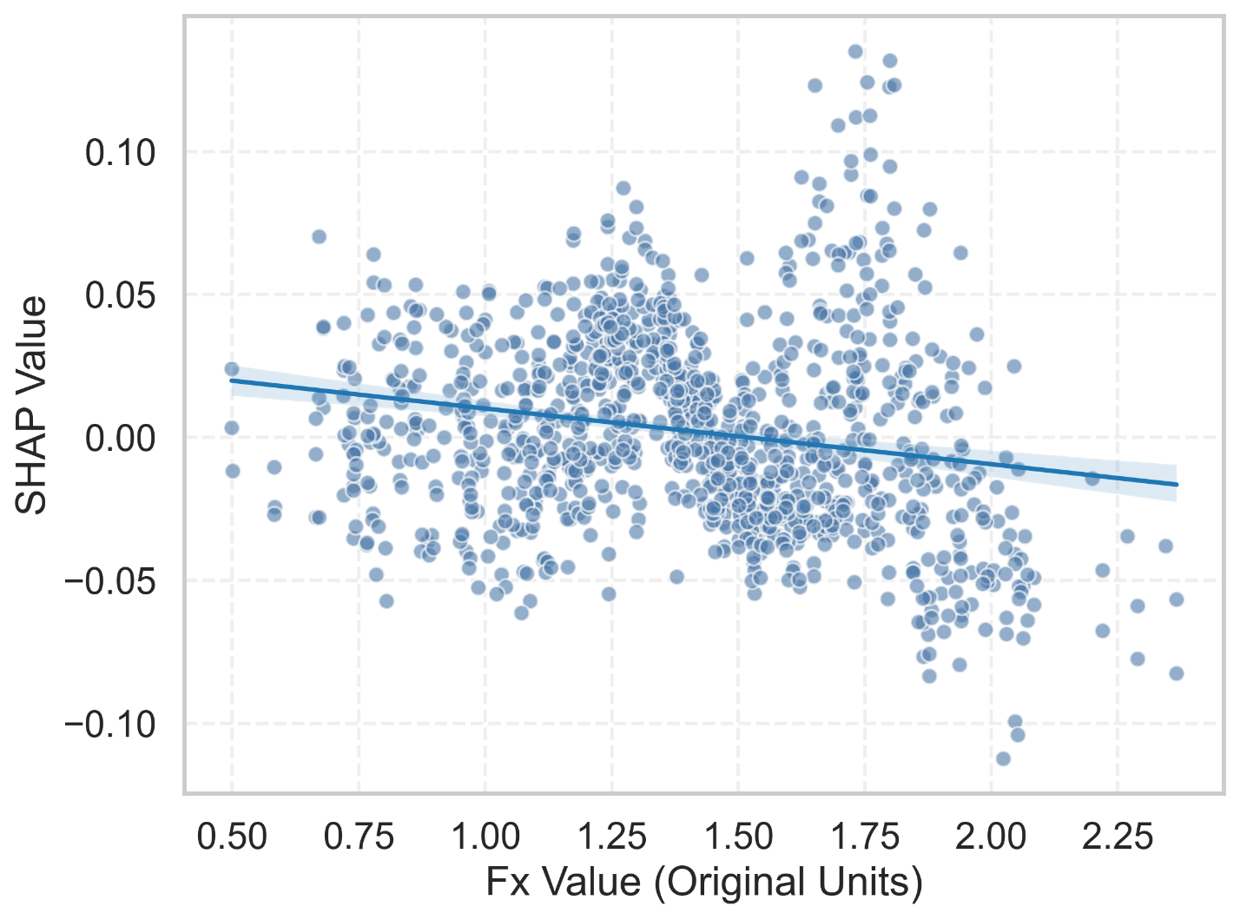
The SHAP values of Fz indicate that as Fz increases, the residual stress tends to become more compressive. However, this trend is relatively weak compared with the influence observed for Fx.

